Combined LUT Calibration and MTPA Control for BLDC Motors with Hall Sensor Misalignment & Large Stator Inductance

Ryan Edric Nashota   
*Mechanical Engineering*  
*University of British Columbia*Vancouver, Canada

rnashota@student.ubc.ca  
 Mark Phung  
*Engineering Physics*  
*University of British Columbia*Vancouver, Canada

marklong@student.ubc.ca  
  
Juri Jatskevich  
*Electrical and Computer Engineering*  
*University of British Columbia*Vancouver, Canada  
jurij@ece.ubc.ca

*Abstract*— Brushless DC (BLDC) motors are extensively utilized in industrial applications, yet they frequently encounter performance limitations due to Hall-sensor misalignment and significant stator inductance. These non-idealities manifest as torque ripple, acoustic noise, and a reduction in torque-per-ampere capability. This paper presents a unified control strategy that synergizes a lookup-table (LUT) based Hall-sensor calibration with a Maximum Torque Per Ampere (MTPA) Proportional Integral (PI) controller. The proposed calibration routine employs an extrapolated averaging technique to rectify commutation intervals without introducing filter delays. Concurrently, the MTPA controller dynamically compensates for the current phase lag by adjusting the advance firing angle, thereby driving the average d-axis current to zero. Verification through detailed machine simulations confirms that the combined approach effectively restores balanced commutation and enhances torque generation efficiency compared to uncompensated baselines.

Keywords— BLDC motor, Hall-sensor misalignment, MTPA, Lookup Table (LUT), Advance Angle Control.

# Introduction

Brushless DC (BLDC) motors are widely used in modern industries such as electric mobility, robotics, manufacturing, and industrial automation due to their high-power density, good reliability and efficiency, superior torque-speed characteristics, simplicity, and low cost [3], [4]. Among various motor drive methods, Hall-sensor-controlled BLDC machines are commonly chosen for their ability to operate at a wide range of speeds and in applications where sensorless control may not be preferred [3], [4].

A BLDC motor consists of a permanent magnet synchronous machine (PMSM), which is electronically commuted by a voltage source inverter (VSI). A schematic diagram of a typical BLDC motor drive is shown in Fig. 1-1, where the VSI is controlled using three Hall sensors that detect the rotor position [5]. Each Hall sensor outputs a square wave signal with a value of 1 or 0, depending on the rotor position. To provide six evenly spaced readings, the three Hall sensors must be spaced apart by 120◦ [5]. In the 120◦ commutation scheme used in this work, each phase conducts for two-thirds of the electrical cycle [7]. In common operating mode (COM), the VSI shifts its switching by 30◦ ahead of the Hall state transitions [8]. When stator inductance is negligible, the 30◦ shift aligns the fundamental component of the phase current with the phase back electromotive force (EMF), thus enabling maximum torque-per-ampere (MTPA) operation [8]. However, motors with significant stator inductance require dynamic adjustment of the advance firing angle to maintain MTPA operation.

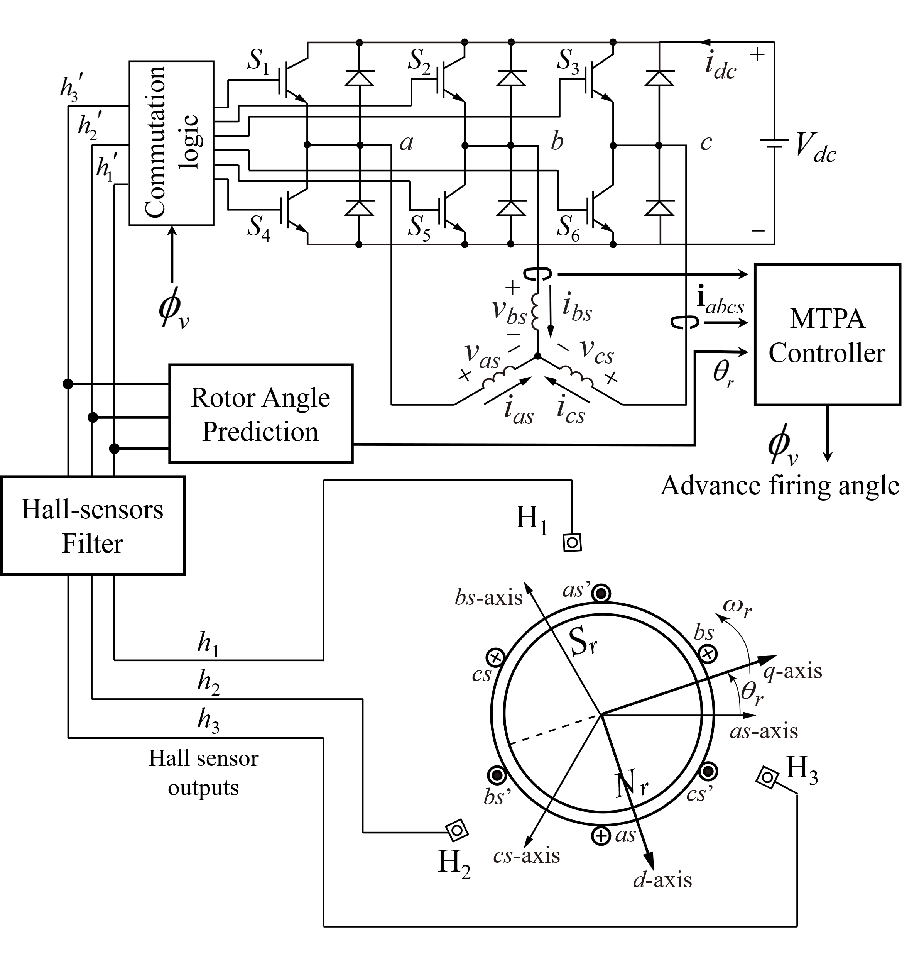

Fig. 1. Diagram for a Hall-sensor controlled BLDC motor driven by a VSI. The misaligned Hall sensors are passed through the proposed algorithm.

Furthermore, manufacturing imperfections cause the Hall sensors to deviate from their intended 120◦ spacing, resulting in asymmetric commutation timing as shown in Figure 4. This leads to imbalanced currents across phases, elevated torque oscillations, and overall degradation of motor performance [6]–[9]. Signal conditioning techniques, including moving average filters, have been applied to Hall sensor outputs [6], [9], yet these introduce timing delays that further compromise MTPA alignment. In motors with large winding inductance, proportional-integral controllers have been developed to dynamically adjust the commutation advance angle [10]–[12]. However, these compensation strategies rely on accurate rotor position estimation, which becomes unreliable when the Hall sensors themselves are misaligned.

Thus, to combat these problems, this paper builds upon previous work and presents a practical dual-strategy approach combining lookup table (LUT) calibration [2] with dynamic MTPA advance angle control [1] to simultaneously correct for Hall sensor positioning errors and compensate for inductance related phase lag in 120◦ commutation mode. The proposed method is validated through simulation using MATLAB/Simulink on an industrial BLDC motor model exhibiting significant Hall misalignment and high winding time constant.

# Modeling of the BLDC System

## Modeling of the PMSM

The BLDC motor will be modeled as a surface-mounted Permanent Magnet Synchronous Machine (PMSM) [3]. For this machine topology, the direct and quadrature axis inductances are equal, that is, Ld = Lq = Ls where Ls denotes the synchronous inductance, Ld the direct axis inductance and Lq the quadrature axis inductance. We will show later that this equality simplifies the analysis and is a defining characteristic of surface-mounted PMSMs.

The stator voltage equation in the stationary abc reference frame can be expressed as: $$\begin{aligned}{\text{v}}_{\text{abc}}\text{=}{\text{R}}_{\text{s}}{\text{i}}_{\text{abc}}\text{+}{\text{L}}_{\text{s}}\frac{\text{d}}{\text{dt}}{\text{i}}_{\text{abc}}\text{+}{\text{e}}_{\text{abc}}, \#(1)\end{aligned}$$

where ${\text{v}}_{\text{abc}}$, ${\text{i}}_{\text{abc}}$, and ${\text{e}}_{\text{abc}}$ are the phase voltage, current, and back-EMF vectors respectively, and ${\text{R}}_{\text{s}}$ is the stator resistance. While the abc frame provides a direct physical representation of the machine quantities, Maximum Torque Per Ampere (MTPA) control design is significantly simplified by converting to the synchronous rotating reference frame. To facilitate MTPA, we transform the system variables into the dq reference frame using the Park transformation matrix ${\text{K}}_{\text{s}}^{\text{r}}\left({\text{θ}}_{\text{r}}\right)$ given by



where *θr* is the electrical rotor position.

Applying the Park transformation to (1.1), we obtain the dynamic equations in the *dq* frame [3]:

$$\begin{aligned}v_{q}=R_{s}i_{q}+L_{q}\frac{di_{q}}{dt}+ω_{r}L_{d}i_{d}+ω_{r}ψ_{m},\#\left(3\right)\end{aligned}$$

$$\begin{aligned}v_{d}=R_{s}i_{d}+L_{d}\frac{di_{d}}{dt}-ω_{r}L_{q}i_{q},\#\left(4\right)\end{aligned}$$

where *ωr* is the electrical rotor speed, *ψm* is the permanent magnet flux linkage, and the coupling terms *ωrLdid* and *ωrLqiq* represent the rotational back-EMF components in each axis.

Mechanical dynamics is defined as

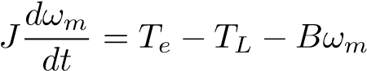, (5)

where *J* is the rotor inertia, *ωm* is the mechanical rotor speed, *TL* is the load torque, *B* is the viscous friction coefficient, and *Te* is the electromagnetic torque. The electrical and mechanical speeds are related by *ωr* = *Pωm*, where *P* is the number of pole pairs.

By the principle of electromechanical energy conversion [3], the electromagnetic torque for a machine with *P* pole pairs is given by

$$\begin{aligned}T_{e}=\frac{3P}{2}\left[ψ_{m}i_{q}+\left(L_{d}-L_{q}\right)i_{d}i_{q}\right].\#\left(6\right)\end{aligned}$$

By recognizing that for the surface-mounted PMSM, where Ld = Lq = Ls, the reluctance torque term (Ld − Lq)idiq vanishes, and the voltage equations also simplifies with Ld = Lq = Ls. Hence the torque equation reduces to

$$\begin{aligned}T_{e}=\frac{3P}{2}ψ_{m}i_{q}.\#\left(7\right)\end{aligned}$$

Notice from (7) that the d-axis current $i_{d}$ does not contribute to the electromagnetic torque production. To maximize torque efficiency and minimize losses per ampere, the optimal control strategy should maintain $i_{d}=0$, thereby aligning all stator current with the torque-producing q-axis.

In the context of six-step commutation, the controller must regulate the commutation instants to maintain the time average d-axis current magnitude close to zero while maximizing the q-axis current component [1], [7]. This ensures efficient operation and maximum torque output for a given current magnitude.

## Inductive Phase Lag and Angle Compensation

In the six-step 120º commutation logic, the six transistors in Fig. 1 are operated according to the sequence depicted in Fig. 2, determined by the estimated rotor electrical angle and the advance firing angleEven though the fixedin COM approximates MTPA satisfactorily for motors with small winding time constant [7], the mismatch of phase current and back EMF worsens for high-performance machines with large inductance. As shown in Fig. 3, for a generic BLDC with a large stator winding time constant, the advance firing angle must be compensated by angleto recover the MTPA condition. Moreover, sincegenerally depends on the machine parameters and the operating condition, [7] previously proposed a dynamic PI controller to determineby regulatingHowever, this method works poorly under Hall-sensor misalignment that leads to higher phase current distortion and inaccurate rotor position estimation.

## Impact of Hall Sensors Misalignment

The misalignment of Hall sensors from their ideal positions leads to deviation of the switching instances away from their designated timings shown in Fig. 2. The problem stems from the inherent mechanical tolerances during manufacturing, especially in low-cost motors. Fig. 4 shows an example of misaligned Hall sensors. Fig. 5 shows measured phase current waveforms of a typical BLDC motor operating with original (unfiltered) Hall sensor signals. The relative offset of the sensors makes some switching intervals longer while others shorter, leading to unbalanced phase currents and higher torque ripple. This condition introduces a higher ripple in speed and angle prediction, which degrades the MTPA PI controller.

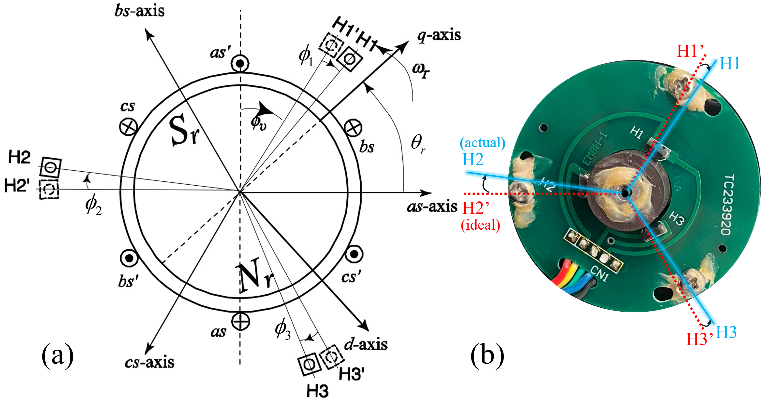

Fig. 4. Misalignment of Hall sensors in a typical BLDC motor.

# Proposed Control Method

## Hall sensor signals Filter via Extrapolated Averaging

This paper builds upon the averaging method proposed in [10] to construct a microcontroller-efficient routine among several proposed Hall-sensor filters. Fig. 5 shows the measured phase current waveforms of the considered BLDC motor operated using 120º commutation logic. Letbe the discrete-value sequence of time intervals between consecutive Hall state transitions, which are marked by a rapid change in phase currents. Due to Hall-sensor misalignment, the discrete sequence  is non-uniform with harmonics [see bottom of Fig. 5]. To balance the intervals, the harmonics can be significantly attenuated using averaging filters of the form [10]

   
The 6-step averaging filter with quadratic extrapolationis selected for the proposed method for its excellent transient response [10], where



The filter is implemented on a microcontroller using interrupt service routines (ISR) and a global timer (details in Section IV). Let  denote the most recent hardware Hall transition time instance. The next scheduled software Hall transition is determined by



where is a correction time to be calculated from the previous time durations [10]. For the filter defined in , the correction time is [10]



## MTPA PI Controller via Compensation of Firing Angle

For BLDC motors with large winding time constant, the optimal MTPA condition can be recovered by adjusting the advance firing anglesuch that the time-averaged *d-*axis currentconverges to zero via a PI controller [7]. Higher output electromagnetic torqueis achieved as the phase currents are phase-aligned with the corresponding back EMFs for the compensated angleThe PI controller scheme is shown on top of Fig. 7, where the *d*-axis current and

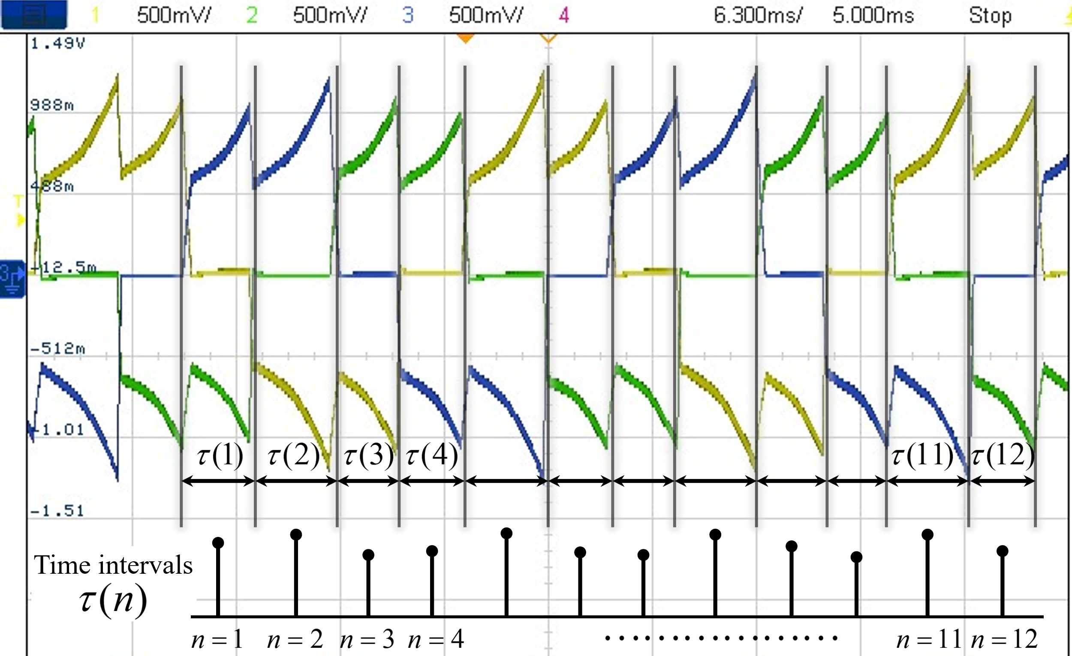

Fig. 5. Switching time intervals distortion due to Hall-sensor misalignment measured on the considered industrial BLDC (see Appendix) in steady-state.

its time-averaged value are computed as





where *T* is the time duration of one electrical cycle and is the estimated electrical speed. In practice, the averaging may be carried out over one switching interval. Together, the Hall-sensor filter and the MTPA controller simultaneously influence the commutation time of the power transistors,

.

Thus, the proposed method can dynamically adjust and achieve the optimal operation in real-time.

# Implementation on Microcontroller

The proposed combined control method has been implemented on Texas Instrument (TI)’s TMDSCNCD28035 C2000TM real-time microcontroller unit (MCU). The MCU is integrated into the TI F28035 control card as part of the DRV8301-HC-EVM VSI development board. However, the algorithm described in this section is readily implementable in any other microcontroller. The motor drive parameters are summarized in the Appendix.

## Implementation of Hall-Sensor Filter

Fig. 6 shows the proposed Hall-sensor filter control algorithm implementation. A recurrent PWM-frequency task (Fig. 6(a)) is used to trigger both the hardware and software interrupt service routines (ISR) to calculate the filter correction time and advance the filtered Hall state, respectively. The hardware ISR (Fig. 6(b)) runs once at every transition of the unfiltered Hall signal. For the convenience of keeping track of the switching intervals, the switching state is defined as [5]

.

This hardware ISR updates the memory of the last six time intervals between Hall state transitions, from which the correction time is calculated to schedule the next software ISR. The scheduled software ISR (Fig. 6(c)) then advances the filtered Hall state.

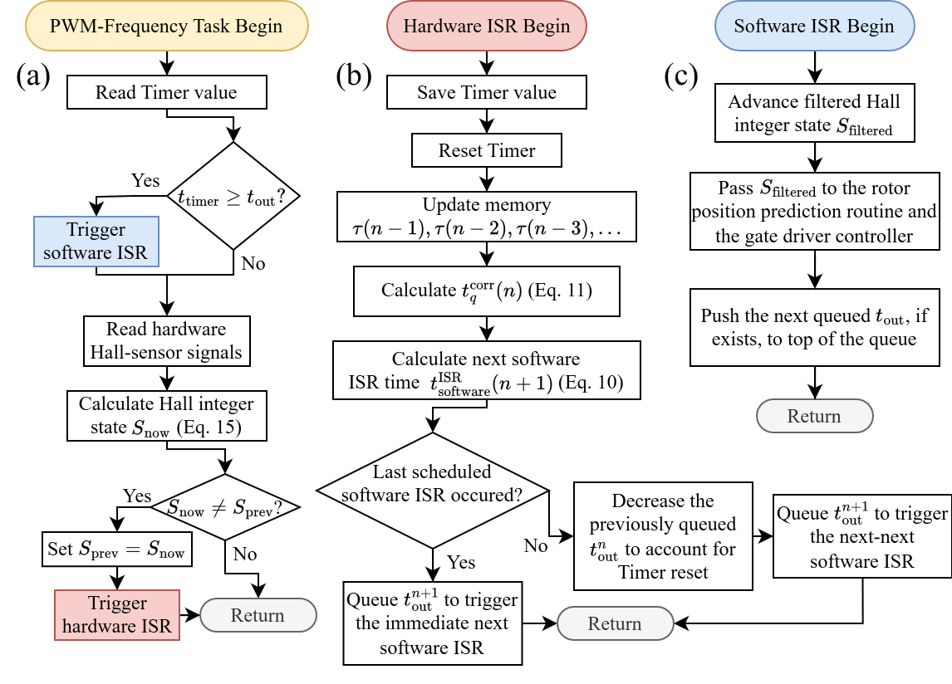

Fig. 6. Flowchart of (a) the PWM-frequency task controlling the hardware and software ISRs, (b) the hardware ISR, and (c) the software ISR to implement the proposed Hall-sensor filtering method on a microcontroller.

Due to Hall-sensor misalignment, some time intervals are longer than others, which implies that the following hardware ISR might be triggered again before the last scheduled software ISR occurs. In this case, the previously scheduled time is decreased to account for resetting the timer, and the new scheduled time is simply queued so as not to overwrite the last untriggered ISR. The PWM-frequency task continuously checks the current timer value to trigger the software ISR (Fig. 6(c)), advancing the filtered Hall state output by one interval. The software ISR should be triggered before the hardware ISR within the PWM-frequency task to reduce complications due to timer resetting.

## Implementation of MTPA PI Controller

After the Hall-sensor filter is enabled to balance the switching intervals, the MTPA PI controller scheme, as shown in Fig. 7(a), is activated to forceby compensating the advance firing angle byThe continuously estimated rotor electrical angle  (required for calculation of  is obtained using linear extrapolation between the filtered Hall state transitions [5]. The microcontroller implementation of the MTPA method is shown in Fig. 7(b). The PWM-frequency task calculates the instantaneoususing and accumulates these values to compute the average at the end of each switching interval. The compensating advance firing angleis updated only once per switching interval. The closed-loop MTPA PI controller parameters are summarized in the Appendix. The Hall-sensor filter routine should be enabled before the MTPA controller, after which both routines are run simultaneously in the same PWM-frequency task to achieve the Hall-sensor filtering and MTPA operation.

# Experimental Results

The proposed combined control method and its microcontroller implementation have been validated experimentally using a typical industrial low-cost BLDC motor

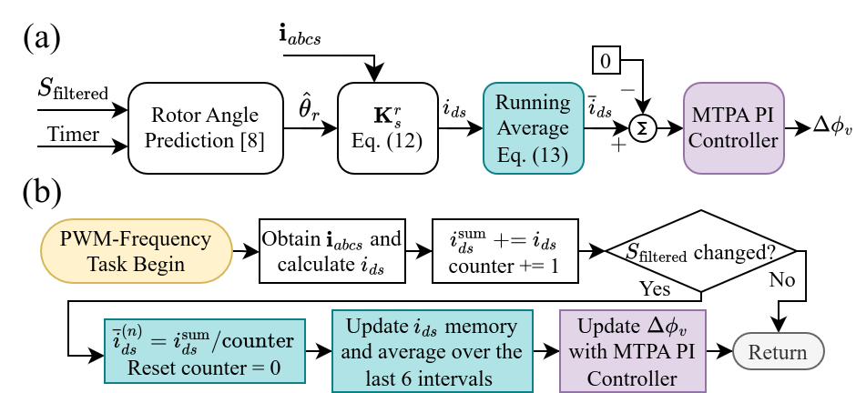

Fig. 7. (a) Flowchart of the proposed MTPA PI controller method and (b) its firmware implementation on a microcontroller (concurrent with Hall filter).

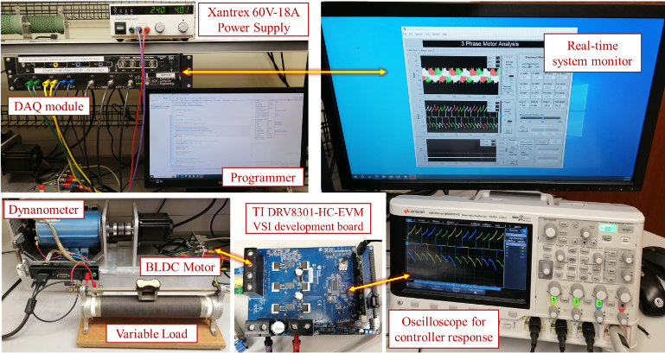

Fig. 8. Experimental BLDC motor drive setup and data acquisition equipment.

with considerable misalignment of Hall sensors and a large stator time constant (motor parameters in the Appendix).

The experimental setup is shown in Fig. 8. The BLDC motor is driven using the DRV8301-HC-EVM development inverter board, which is powered by a DC power supply. The motor operates against a DC dynamometer variable load torque. The phase currents are measured using Micsig 0.1V/A current clamp probes and captured on an oscilloscope. To capture the control response in real-time, the run time variables such as are also output to the Keysight oscilloscope using integrated digital-to-analog converters (DAC) on the TI development inverter board.

Fig. 9 shows the phase current waveforms for the considered motor operating in a steady state at and Nm. Initially (see the left side of Fig. 9(a)), the Hall-sensor misalignment leads to unbalanced time intervalsbetween the Hall state transitions, which leads to distorted phase currents, high torque ripple (and even higher audible noise). After the Hall-sensor filter routine is enabled (see right side of Fig. 9(a)), the time intervals became significantly more balanced, resulting in much more uniform phase currents. The small differences between the peaks of currents may be attributed to the motor shaft and the dynamometer coupler.

The condition is now ready to enable the MTPA PI controller (see the left side of Fig. 9(b)). After the MTPA controller is enabled, the balanced time intervals  are not compromised. At the same time, the peaks of the phase currents are noticeably reduced, suggesting that higher efficiency is achieved at the same torque operating point.

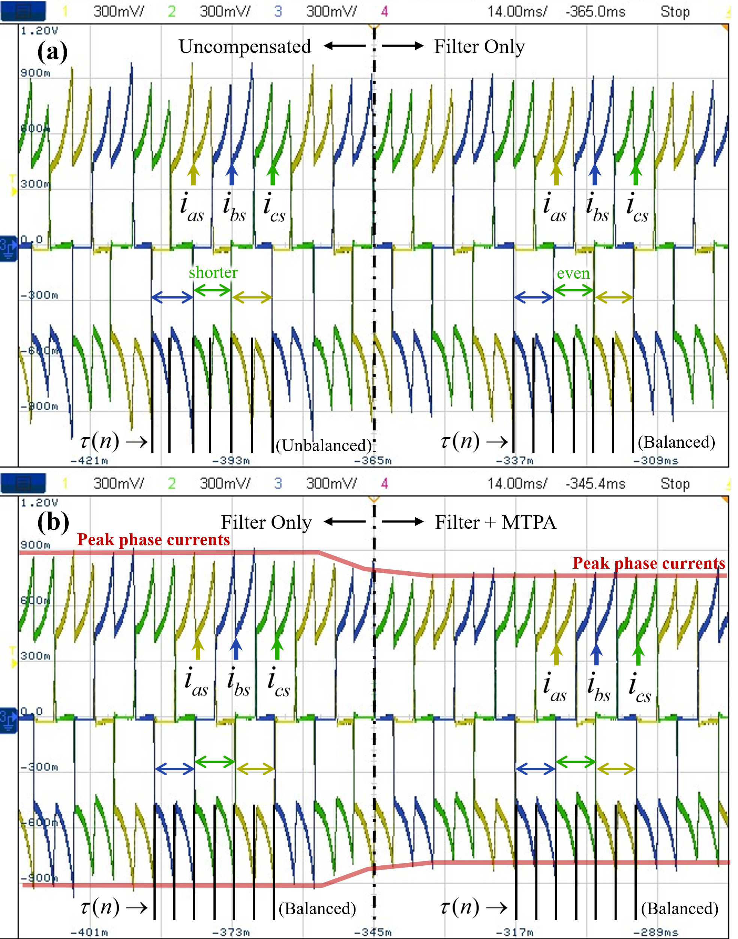

Fig. 9. Measured phase current waveforms observed on an oscilloscope: (a) moment of enabling filtering of Hall sensor signals, and (b) activation of MTPA PI controller

To validate the MTPA condition, Fig. 10 shows the responses of the phase current average *d-*axis currentand the compensation advance firing angle at the moment of MTPA PI controller enabling time for small (see Fig. 10(a)) and nominal (see Fig. 10(b)) output electromagnetic torque. In both cases, when the proposed MTPA controller is enabled, rapidly converges to zero over a few switching intervals andalso converges to the optimal value to achieve MTPA. The finalvalues are different for the two different operating points, indicating that the proposed method can dynamically achieve MTPA in real-time under various conditions. Indeed, the peak phase current decreases considerably when the MTPA controller is enabled for the same output torque 

After the initial enabling sequence, the Hall-sensor filter and the MTPA PI controller operate simultaneously. In particular,should be maintained by dynamically updatingunder changing operating conditions. Fig. 11 shows a transient response of the system under the step-up and step-down changes of output torque between 0.51 Nm and 1 Nm (by changing the duty cycle for a fixed load and fixed  During step-up torque transient (see Fig. 11(a)), increases rapidly from 7.08° to 11.34° over a few switching intervals. This is consistent with the longer current commutation time at higher torque, which worsens the phase shift between the phase current and back EMF. Despite small fluctuations during the transient, is sustained before and after the change. Similarly, during the step-down transient (see Fig. 11(b)),

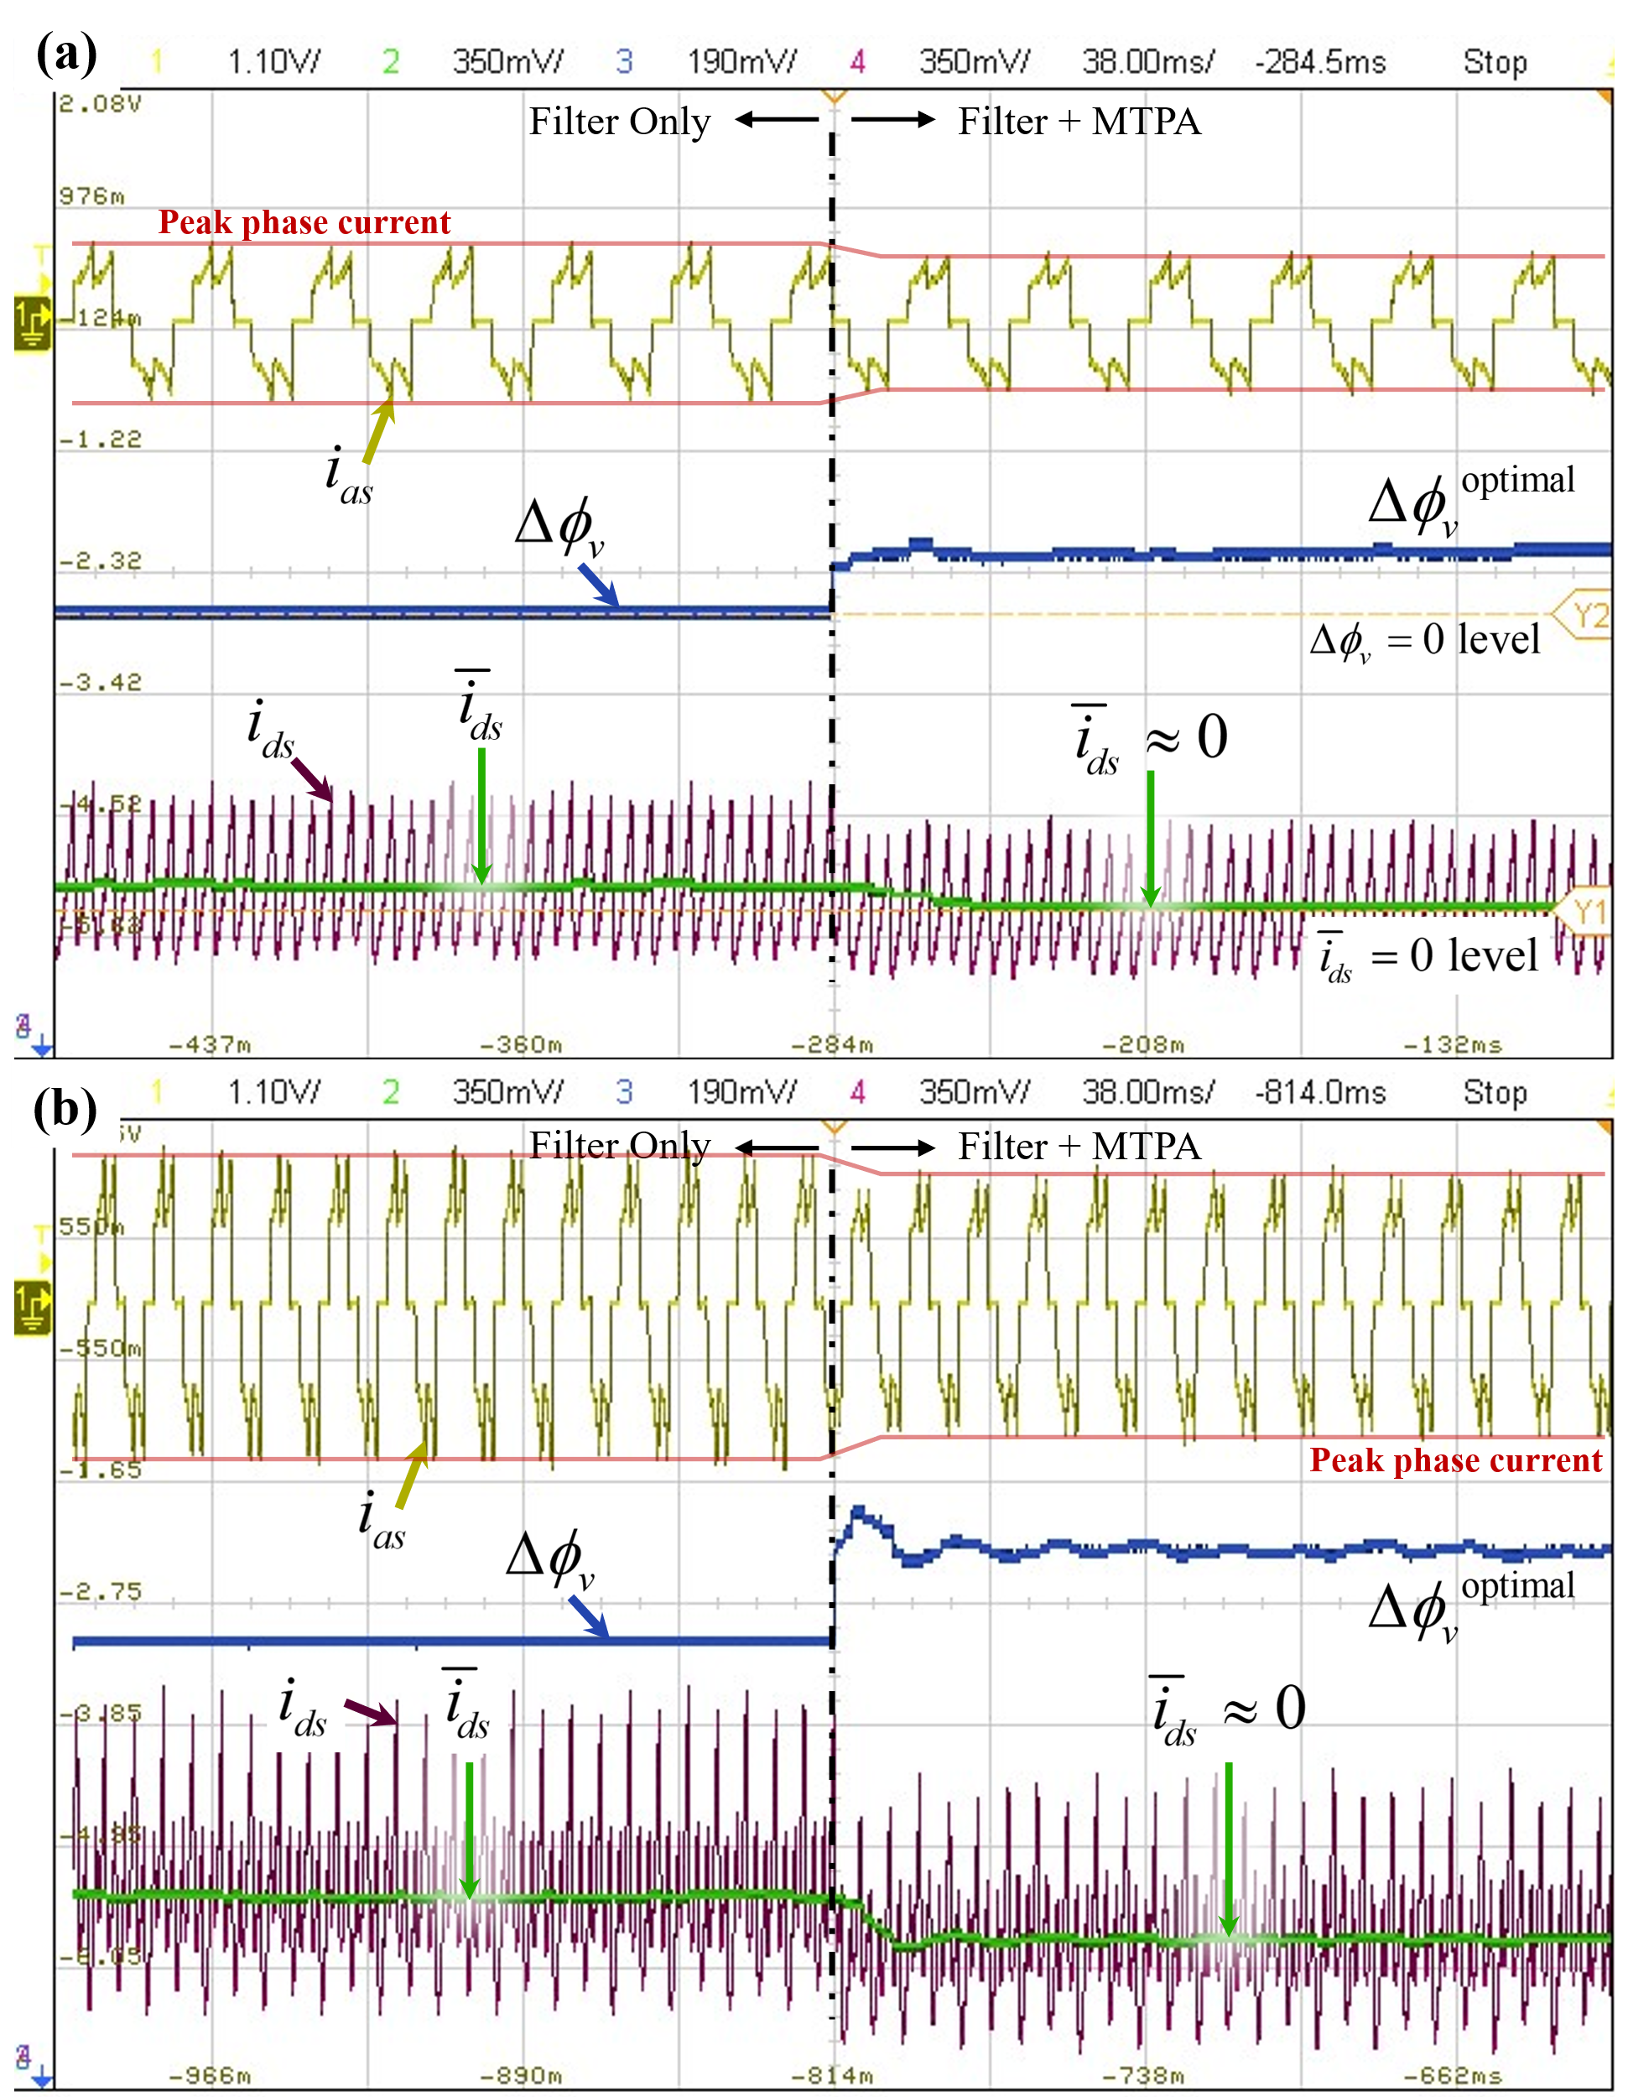

Fig. 10. Responses of phase current*d-*axis currentandand the compensating advance firing angleat the MTPA PI controller enabling time for the considered BLDC motor at: (a) operating point defined by, and (b) operating point defined by  .

returns to the initial value of 7.08° and the MTPA operation is sustained. This experiment shows that the proposed combined method operates dynamically and stably to achieve MTPA with a very fast response to changes in operating point.

Finally, a sweep of the torque-per-Ampere ratio, defined asfor the BLDC motor drive with enabled Hall sensor filter routine and with/without the MTPA PI controller over a wide range of output electromagnetic torque is shown in Fig. 12. The compensating angle is also plotted in Fig. 12 (with the vertical axis on the right side). As seen in Fig. 12, at every output torque value, the torque-per-Ampere ratio is higher when the MTPA PI controller is enabled compared to a common operating mode (COM) that just uses the Hall signals. As torque and current magnitude increase, the current commutation time also increases, requiring a larger compensation of advance firing angle At larger torques, thebecomes more significant (up to 15°) and an increasing improvement over the COM can be expected. The results in Fig. 12 show that the torque-per-Ampere improvement of using the proposed MTPA controller increases with increasing torque. This demonstrates that the proposed combined method can accurately adjust the firing angle  to achieve MTPA for BLDC motors with Hall-sensor misalignment and large winding inductance over a wide range of operating conditions.

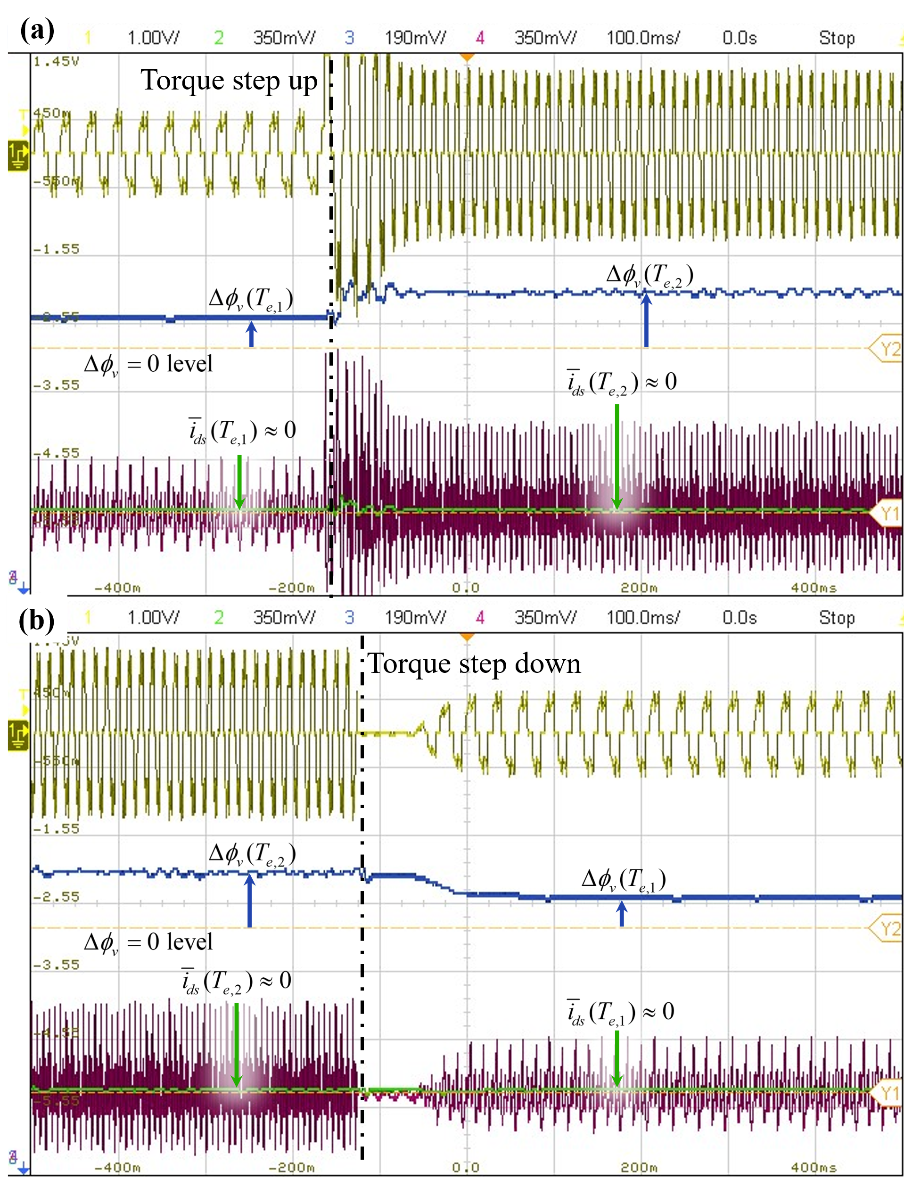

Fig. 11. Responses of phase current*d-*axis currentandand the compensating advance firing angleunder output electromagnetic torque step up and step down transients withand

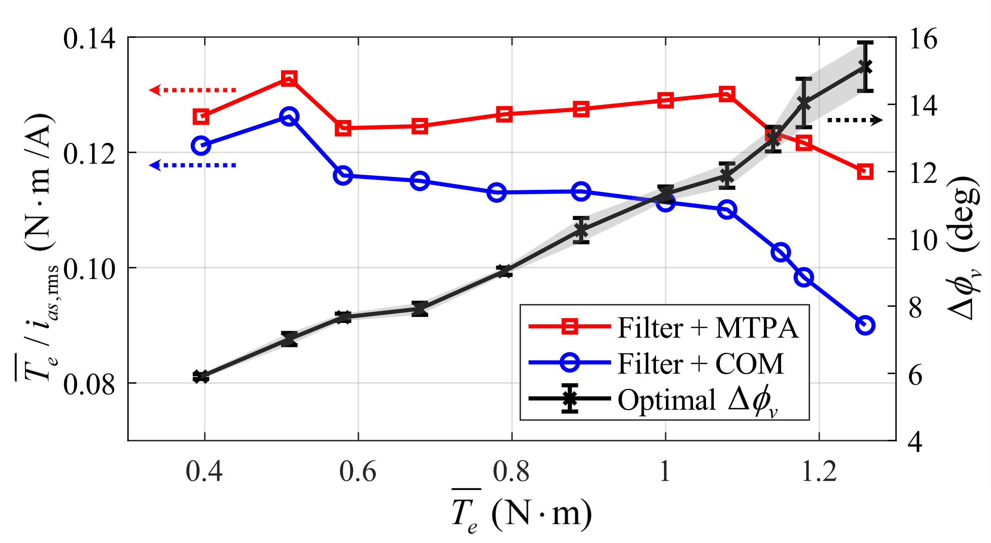

Fig. 12. Torque-per-Ampere ratio and compensating advance firing angleto achieve MTPA for different values of output torque

# Conclusion

This paper aims to simultaneously solve the challenges of achieving MTPA operation for very common low-cost industrial BLDC motors with Hall-sensor misalignment and large winding inductance. The proposed method is developed assuming the most commonly used six-step 120° commutation. When using the previously developed Hall-sensor filtering alone, the mismatch between the fundamental component of the phase current and the corresponding back EMF increases, deviating from optimal MTPA condition. At the same time, using an MTPA controller without effective Hall-sensor filtering leads to oscillations in the firing angle compensation due to the unbalanced switching intervals. To address both problems, a control method integrating the Hall-sensor filtering and the MTPA PI controller is proposed.

The detailed implementation of the proposed combined method on a microcontroller is validated with experiments on a typical industrial BLDC motor with significant misalignment of Hall sensors and large stator winding inductance. The proposed method successfully mitigates errors in Hall sensor signals while achieving MTPA operation over a wide range of operating conditions and transients. Future research will investigate the dynamic tuning of the MTPA PI controller based on speed to optimize the firing angle response and implement a look-up-table-based Hall-sensor filter to improve torque-speed response during significant transients.

##### Appendix

*A) BLDC parameters*: Arrow Precision Motor Company, Ltd., Model 86EMB3S98F, 36V, 2000 r/min, 8 poles, ,,, 

*Estimated Hall-sensor misalignment*: 

*MTPA PI controller parameters:* 

*B) Microcontroller:* DRV8301-HC-EVM VSI development board with TI F28035 control card (TI C2000TM MCU series).

*Measurement equipment*: oscilloscope Keysight DSOX2004A, current clamps probes Micsig CP503B 0.1V/A, differential voltage probes Micsig DP10007 100MHz.

##### References

1. A. Ghayth and M. Şimşir, “Recent Trends and Challenges of Electric Motor Technologies,”  *Int. J. Electr. Eng. and Sustain.*, vol. 1, no. 2, pp. 21–28, Nov. 2023.
2. P. C. Krause, Oleg Wasynczuk, S. Pekarek, and T. O’Connell, *Electromechanical Motion Devices: Rotating Magnetic field-based Analysis with Online Animations*. Hoboken: Wiley-Ieee Press, 2020.
3. D. Mohanraj *et al.*, “A Review of BLDC Motor: State of Art, Advanced Control Techniques, and Applications,” *IEEE Access*, vol. 10, pp. 54833–54869, 2022.
4. S. D. Sudhoff and P. C. Krause, “Operating modes of the brushless DC motor with a 120 degrees inverter,” *IEEE Transactions on Energy Conversion*, vol. 5, no. 3, pp. 558–564, 1990.
5. J. Zhou, S. Ebrahimi, and J. Jatskevich, “Extended Operation of Brushless DC Motors Beyond 120° under Maximum Torque Per Ampere Control,” *IEEE Transactions on Energy Conversion*, vol. 38, no. 2, pp. 1–12, 2023.
6. P. Alaeinovin, S. Chiniforoosh, and J. Jatskevich, "Evaluating misalignment of hall sensors in brushless DC motors," in *Proc. IEEE Canada Electric Power Conf.*, Oct. 2008, pp. 1–6.
7. J. Zhou, J. Lu, S. Ebrahimi, and J. Jatskevich, “A Compensation of Commutation Angle in Hall-Sensor-Controlled Brushless DC Motors for Maximum Torque per Ampere Operation,” *2022 21st International Symposium INFOTEH-JAHORINA (INFOTEH)*, pp. 1–6, Mar. 2022.
8. F. Ghavamirad and A. Rezazadeh, “Investigating the effect of Hall effect sensor position error on BLDC motor torque,” *International Journal of Electric and Hybrid Vehicles*, vol. 16, no. 4, pp. 358–373, Jan. 2024.
9. N. Samoylenko, Q. Han, and J. Jatskevich, “Balancing Hall-Effect Signals in Low-Precision Brushless DC Motors,” *APEC 07 - Twenty-Second Annual IEEE Applied Power Electronics Conference and Exposition*, pp. 606–611, Feb. 2007.
10. N. Samoylenko, Q. Han, and J. Jatskevich, “Dynamic Performance of Brushless DC Motors With Unbalanced Hall Sensors,” *IEEE Transactions on Energy Conversion*, vol. 23, no. 3, pp. 752–763, Sep. 2008.
11. B. Tan, X. Wang, D. Zhao, K. Shen, J. Zhao, and X. Ding, “A Lag Angle Compensation Strategy of Phase Current for High-Speed BLDC Motors,” *IEEE Access*, vol. 7, pp. 9566–9574, 2019.
12. X. Shi, X. Wang, C. Gu, and Z. Deng, “A novel commutation correction method for high-speed PM brushless dc motor,” *2022 IEEE Applied Power Electronics Conference and Exposition (APEC)*, pp. 1899–1905, Mar. 2017.